**Pizza Sales Analysis**

(Analyzing trends and insights for better business decisions)

Muhammad Kashif Abdullah | Trainee @atomcamp

**Table of Content:**

Overview ----------------------------------------------------------- page 3

Introduction ------------------------------------------------------- page 3

Data Description -------------------------------------------------- page 3

Methodology ------------------------------------------------------- page 4

Analysis & Findings ------------------------------------------------ page 4

Recommendations ------------------------------------------------- page 7

Summary ------------------------------------------------------------ page 8

**Obstract:**

In today's world, making data-driven decisions is crucial for business growth. A pizza shop wants to increase its sales by analyzing data and identifying trends.

This pizza sales analysis report highlights key trends that will help the pizza shop in future planning to grow its business.

**Introduction:**

The food industry is highly competitive, and making data-driven decisions is essential to staying ahead in this race.  
This report analyzes key insights, including Top-Selling Pizza Categories, Revenue by Size, Peak Hours, Premium vs. Standard Options, Monthly Sales Trends, and Shift-Wise Category Sales. These insights will help the pizza shop with future planning and strategic decision-making.

**Data Description:**

**Source:** The dataset used provided by the @atomcamp.

The dataset contains sales data from a pizza shop, including details on pizza categories, sizes, sales times, and revenue.

**Key features of the data:**

* Order ID: Unique identifier for each sales.
* Pizza Name: Name of the pizza sold.
* Category: Pizza type (Premium or Standard).
* Size: Size of the pizza (Small, Medium, Large).
* Order Time: Time the order was placed.
* Revenue: Total revenue generated per sales.
* Shift: Time of day when the order made (Morning, Afternoon, Evening).

**Data Quality Issues & Cleaning:**

* **Missing Values:**
* **Duplicates:** Removed duplicate entries to ensure accurate analysis.
* **Time format:** Converted the order time to a standard 24-hour format.

**Methodology:**

**Tools & Technologies Used:**

The analysis was conducted using **Microsoft Excel**, which was selected for its ease of use in data cleaning, manipulation, and visualization. Key features of Excel used include Pivot Tables for summarizing data and creating a Dashboard for visual representation.

**Analysis & Findings:**

**Top-Selling Pizza Category:**

* The Classic pizza category is the top-performing category, generating nearly $15,000 in revenue.
* It is followed by the Supreme category with approximately $12,000 in revenue.

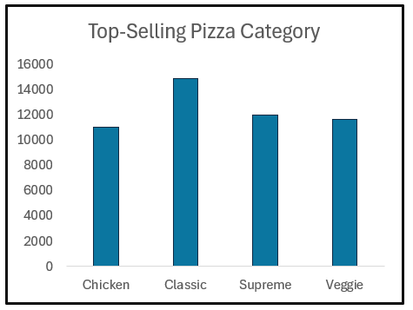

Figure 1

**Revenue by Size:**

* The large-sized pizzas generated the highest revenue, approximately $380,000, followed by the medium sized pizzas, which generated $280,000.

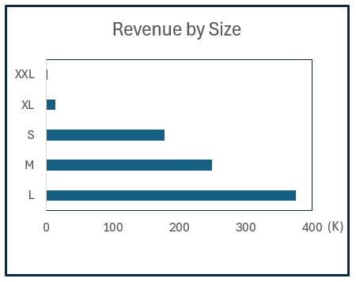

Figure 2

**Peak Hour:**

* The 12:00 PM to 1:00 PM time slot represents the peak sales hour, during which most customer orders are placed.

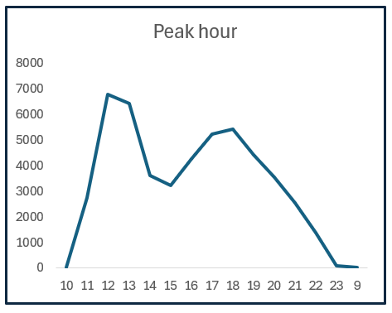

Figure 3

**Premium Vs Standard:**

* Premium Pizzas account for 56% of total revenue.
* Standard Pizzas contribute the remaining 44% of the revenue.

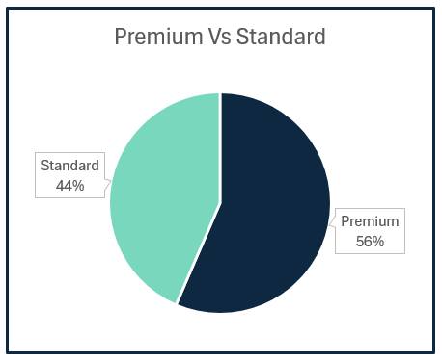

Figure 4

**Monthly Sales Trend:**

* Pizza sales show a significant increase during the months of July and August, indicating a seasonal trend.

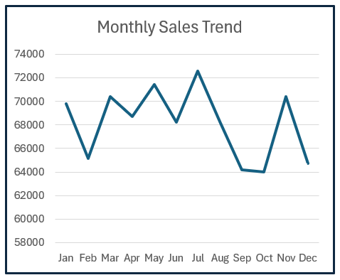

Figure 5

**Shift-Wise Category Sales:**

* The Classic pizza category demonstrates the highest sales distribution across shifts: Morning Shift: 27.5% of total sales.
* Evening Shift: 26.8% of total sales.
* Night Shift: 26.5% of total sales.

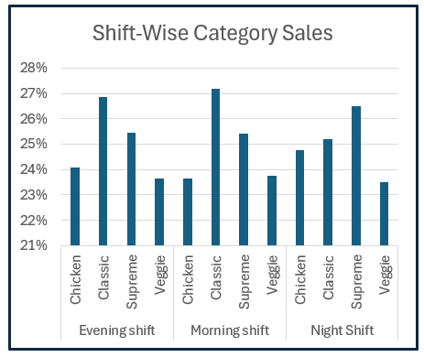

Figure 6

**Recommendations:**

* Expand the Classic Menu: Since the Classic category generates the highest revenue, consider adding more variations or promotional offers to boost its sales further. Marketing Campaigns: Target the Classic category in advertising campaigns to attract more customers.
* Staffing: Ensure adequate staffing and resources during the 12:00 PM to 1:00 PM peak hour to minimize delays and improve customer satisfaction. Pre-Order Options: Promote pre-order services for customers during peak hours to streamline operations.
* Summer Promotions: Since sales peak in July and August, introduce special summer-themed promotions or limitedtime pizza flavors during this period. Stock Management: Ensure sufficient inventory during 05 these months to meet increased demand.
* Use customer feedback and historical data to identify why specific categories or sizes perform better and tailor strategies accordingly. Consider launching surveys or offering discounts in exchange for feedback on new pizza flavors or menu options.

**Summary:**

* The Classic pizza category generates the highest revenue, followed by Supreme, Chicken, and Veggie. Large-sized pizzas lead in revenue, while smaller sizes, especially Extra-Extra-Small, contribute the least. The peak sales hour is 12:00 PM to 1:00 PM. Premium Pizzas account for 56% of revenue, while Standard Pizzas contribute 44%. Sales peak during July and August, showing a seasonal trend. The Classic category has the highest sales across all shifts, with the Morning Shift leading slightly at 27.5%